**Analysis -2**

**No of Vehicles by Brand Available on ebay for sale with the help of visualization.**

* Using seaborn and matplotlib we have created a bar plot

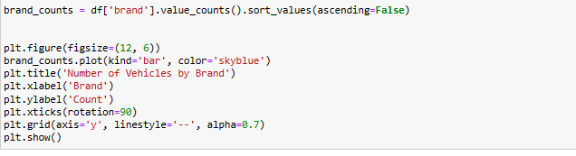

Here is the visualization

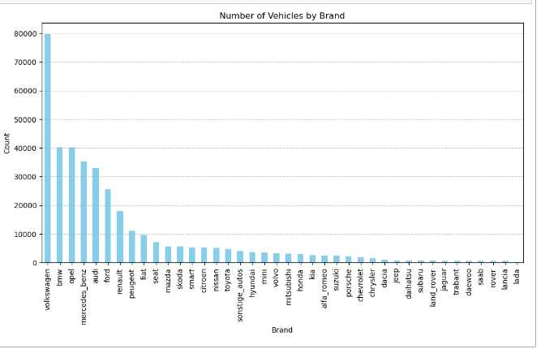

* From the above bar graph we can see the number of vehicles avalibale on ebay based on the brand.
* As we can see the brand “Volkswagen” has the highest count as compared to others
* And we can also intrepet that the brand “lada” has the lowest count.

# What is the Average price for vehicles based on the type of vehicle as well as on the type of gearbox.Explain me with both numerical and visualization analysis.

# Numerical Analysis

# 

# Using groupby() function we have grouped the vehicle type and gearbox and calculated the mean price for each group using mean() function.

# The above numerical analysis shows the average price for each vehicle type based on the gear type.

# Visualization Analysis

# 

# From the above visualisation shows the Average price of vehicles that as gearbox type Automatic and Manually.

# we can see that the “Andere” type of vehicle shows the highest average price which has the gearbox type “manually” compare to automatic.

# What is the marginal probability of private seller

# 

# The marginal probability of a private seller being 1.00 suggests that private sellers are the dominant players in the vehicle market. This has a number of implications for both buyers and sellers.